UF/IFAS Extension Physical Address
4-H Youth Development PO Box 000000
County Gainesville, FL 32611-0000
352-0000-0000
352-000-0000 Fax

Dear Parents,

Congratulations! Your child is about to embark upon the exciting and challenging journey of public speaking.

This week, your child’s school will be participating in the Florida 4-H Public Speaking school enrichment program, powered by Florida Power & Light (FPL). This educational program, designed to introduce fourth, fifth and sixth grade children to the concept of public speaking, is administered by your local UF/IFAS Cooperative Extension Office.

Students throughout Florida will compete in classroom and school-wide speaking contests with winners going on to a county competition.

To prepare your child for this educational opportunity, your child’s teacher has been provided with a series of instructional materials introducing the Florida 4-H Public Speaking school enrichment program. Throughout the week, your child will learn how to research, organize, and deliver a speech topic of their choice. Your child will need your support at home through all stages of the process, from selection of a topic to the preparation of the final speech. Share with them your own public speaking experiences, the good and the bad!

We hope this program will further your child’s confidence and that it will provide a solid foundation for his or her future educational and professional aspirations.

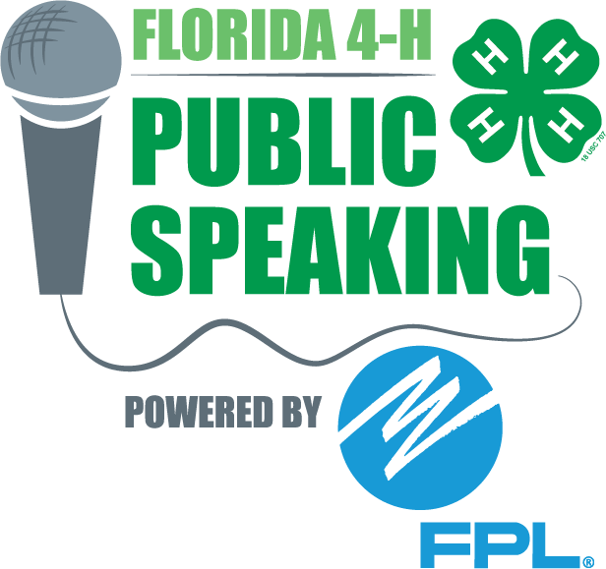
Sincerely,

(INSERT SIGNATURE)

Public Speaking Program Coordinator Name
Position

